

WATER AMMONIUM PERSULFATE Call:

lm(formula = W ~ R + T + L + R \* L + I(L^2), data = A)

Residuals:

Min 1Q Median 3Q Max

-0.0109857 -0.0027571 -0.0007571 0.0029571 0.0110143

Coefficients:

Estimate Std. Error t value Pr(>|t|)

(Intercept) 8.878e-01 1.869e-02 47.506 < 2e-16 \*\*\*

R -2.821e-04 3.993e-05 -7.066 1.01e-06 \*\*\*

T -2.100e-03 2.440e-04 -8.608 5.55e-08 \*\*\*

L 1.530e-02 5.253e-03 2.912 0.00894 \*\*

I(L^2) -1.512e-03 5.905e-04 -2.561 0.01910 \*

R:L 4.405e-05 8.591e-06 5.127 5.99e-05 \*\*\*

---Signif. codes: 0 ‘\*\*\*’ 0.001 ‘\*\*’ 0.01 ‘\*’ 0.05 ‘.’ 0.1 ‘ ’ 1

Residual standard error: 0.005455 on 19 degrees of freedom

Multiple R-squared: 0.9368, Adjusted R-squared: 0.9202

F-statistic: 56.37 on 5 and 19 DF, p-value: 9.746e-11

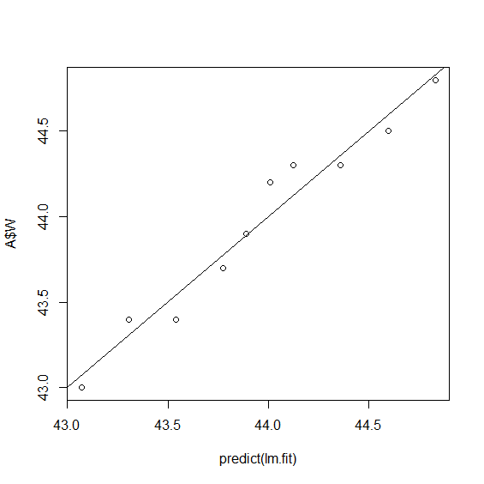

WATER SUGAR

Call:

lm(formula = W ~ R + L, data = A)

Residuals:

Min 1Q Median 3Q Max

-0.14000 -0.07375 -0.04500 0.07375 0.19000

Coefficients:

Estimate Std. Error t value Pr(>|t|)

(Intercept) 47.7550000 0.4647080 102.763 2.18e-12 \*\*\*

R 0.0039167 0.0004869 8.044 8.80e-05 \*\*\*

L -0.8200000 0.0826352 -9.923 2.25e-05 \*\*\*

---Signif. codes: 0 ‘\*\*\*’ 0.001 ‘\*\*’ 0.01 ‘\*’ 0.05 ‘.’ 0.1 ‘ ’ 1

Residual standard error: 0.1307 on 7 degrees of freedom

Multiple R-squared: 0.9589, Adjusted R-squared: 0.9471

F-statistic: 81.58 on 2 and 7 DF, p-value: 1.412e-05

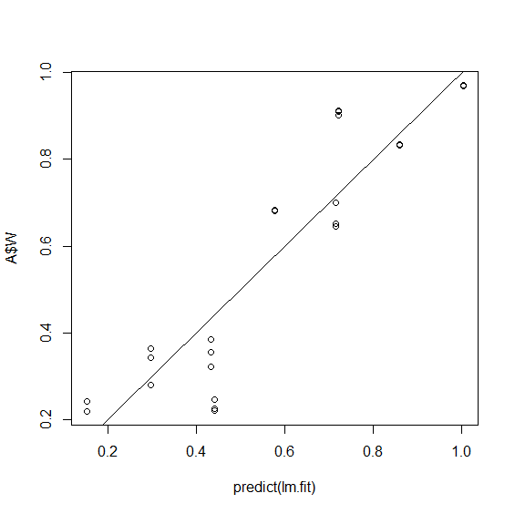

WATER Call:

lm(formula = W ~ L + T, data = A)

Residuals:

Min 1Q Median 3Q Max

-0.22010 -0.05564 -0.02379 0.07737 0.19026

Coefficients:

Estimate Std. Error t value Pr(>|t|)

(Intercept) -1.37999 0.22787 -6.056 2.97e-06 \*\*\*

L -0.14418 0.02750 -5.243 2.25e-05 \*\*\*

T 0.02807 0.00275 10.209 3.28e-10 \*\*\*

---Signif. codes: 0 ‘\*\*\*’ 0.001 ‘\*\*’ 0.01 ‘\*’ 0.05 ‘.’ 0.1 ‘ ’ 1

Residual standard error: 0.1167 on 24 degrees of freedom

Multiple R-squared: 0.8459, Adjusted R-squared: 0.833

F-statistic: 65.86 on 2 and 24 DF, p-value: 1.797e-10